Hobbies
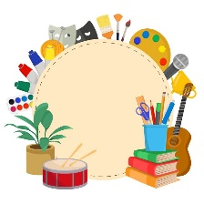
Hobbies are fun activities that we do in our free time. Everyone has different hobbies that they enjoy.
Reading is a popular hobby. Many children like to read story books and comics. You can read anywhere – at home, in the garden, or at the library.
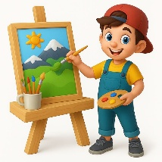 Drawing and painting help us be creative. You can use pencils, crayons, or paints to make beautiful pictures. Some people like to draw animals or landscapes.
Playing sports is a fun way to stay fit. Football, swimming, and cycling are popular sports. You can play with friends or join a team.
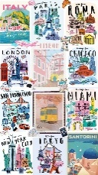Collecting things is another interesting hobby. Some children collect stamps, shells, or stickers. It's exciting to add new items to your collection.
Cooking can be a tasty hobby! You can learn to make simple dishes like sandwiches or biscuits. It's fun to share what you cook with family and friends.
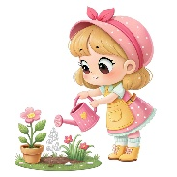Gardening lets you grow plants and flowers. It's amazing to watch seeds turn into plants. You need patience for this hobby!
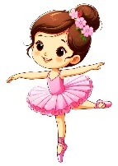Dancing is a lively hobby. You can learn different styles like ballet or street dance. Dancing makes you feel happy and energetic.
Playing music might mean learning an instrument like the piano or guitar. You can play your favorite songs or even write your own music.
Vocabulary։
• hobby - հոբի, սիրած զբաղմունք • free time - ազատ ժամանակ • reading - ընթերցանություն • drawing - նկարչություն • painting - գեղանկարչություն • sports - սպորտ • collecting - հավաքածուներ հավաքել • cooking - խոհարարություն • gardening - այգեգործություն • dancing - պար • music – երաժշտություն

Task 1
Write down which hobby it is.
music
dancing
gardening
cooking
collecting
sports
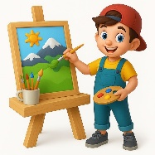 drawing
reading
Task 2
Translate into English. /have-ունենալ,I like-սիրել, I don’t like-չսիրել, favorite hobby-սիրելի հոբին/

Ես ունեմ հոբբի: I have a hobby.
Ես սիրում եմ նկարել և կարդալ: I like to draw and read.
Ես սիրում եմ պարել և սնունդ պատրաստել: I love to dance and cook.
Ես չեմ սիրում զբաղվել այգեգործությամբ: I don't like gardening.
Ես սիրում եմ զբաղվել սպորտով: I like to play sports.
Իմ սիրելի զբաղմունքը կոլեկցիաներ հավաքելն է: My favorite hobby is collecting.

